Project Design Phase-II
Technology Stack (Architecture & Stack)

Date | 3 July 2026
Team ID
Project Name | Comprehensive Analysis and Dietary Strategies with Tableau: A College Food Choices Case Study
Maximum Marks | 4 Marks

Technical Architecture:
The Deliverable shall include the architectural diagram as below and the information as per the table1 & table 2
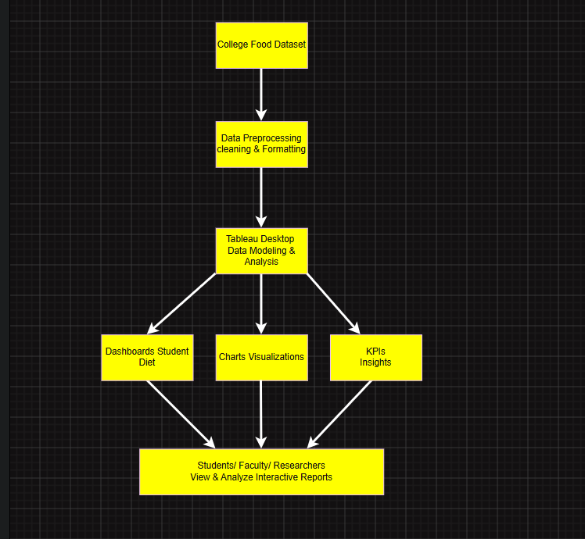

Table-1 : Components & Technologies:
S.No | Component | Description | Technology
 | User Interface | Interactive dashboard for users | Tableau Desktop / Tableau Public
 | Application Logic-1 | Data cleaning and preprocessing | Microsoft Excel
 | Application Logic-2 | Data transformation and calculations | Tableau Calculated Fields
 | Application Logic-3 | Data visualization and dashboard creation | Tableau Desktop
 | Database | College food choices dataset | CSV Dataset
 | Cloud Database | Not Applicable | N/A
 | File Storage | Store dataset and Tableau workbook | IBM Block Storage or Other Storage Service or Local Filesystem
 | External API-1 | Not Used | N/A
 | External API-2 | Not Used | N/A
 | Machine Learning Model | Not Applicable | N/A
 | Infrastructure (Server / Cloud) | Local System | Windows PC with Tableau Desktop

Table-2: Application Characteristics:
S.No | Characteristics | Description | Technology
 | Open-Source Frameworks | Dataset preprocessing and visualization tools | Tableau Public, Microsoft Excel
 | Security Implementations | Dataset stored locally with restricted access | Local File Permissions
 | Scalable Architecture | Dashboards can be expanded by adding new datasets and worksheets | Tableau Data Model
 | Availability | Dashboard accessible whenever Tableau Workbook is opened or published | Tableau Desktop / Tableau Public
 | Performance | Optimized through data cleaning, filters, calculated fields, and efficient visualizations | Tableau Optimization Techniques

References:
https://c4model.com/
https://developer.ibm.com/patterns/online-order-processing-system-during-pandemic/
https://www.ibm.com/cloud/architecture
https://aws.amazon.com/architecture
https://medium.com/the-internal-startup/how-to-draw-useful-technical-architecture-diagrams-2d20c9fda90d

